COURSE HANDBOOK

OCR
GCSE Drama

©2018CCC

Contents

- Course Content & Structure
- Component 01/02 Devising
- Component 03 Present & Performing Texts
- Component 04 Performance & Response
- Course Expectations
- Coursework Guidelines & Rules
- Referencing & Bibliography
- Homework & Independent Study
- Reading List
- Trips & Enrichment
- Staff Contacts & Concerns

SECTION ONE: Course Content & Structure

The OCR GCSE in Drama consists of Three Components.
- Two of the components are externally assessed.
- One of the components is internally assessed and moderated by OCR.

Content Overview Assessment Overview

Learners will research and explore a stimulus, work collaboratively
and create their own devised drama.

Devising drama (01/02)

60 marks

Non-exam assessment

30%
of total
GCSE

Learners develop and apply theatrical skills in acting or design by presenting a showcase of two extracts from a performance text.

Presenting and performing texts (03)

60 marks

Non-exam assessment
(Visiting examination)

30%
of total
GCSE

Learners will explore practically
a performance text to demonstrate their knowledge and understanding of drama.

Learners will analyse and evaluate a live theatre performance.
Drama: Performance and response
(04)

80 marks

Exam assessment

1 hour 30 minutes

(Written paper)

40%
of total
GCSE

The Structure of Course Delivery**
YEAR  ASSESSED | Externally Assessed Units |  | Internally Assessed Units
Year 9 | Mock – Devising | Mock – Text |  | Mock - Written
Year 10 | Mock - Text |  | ACTUAL: Devising
Year 11 | ACTUAL: Text |  | ACTUAL: Written
** Correct as of August 2018

Year 9
You will cover all three components of the course – having a chance to learn the content of the unit and then have mock assessment of each part.
This will lay the foundation of knowledge for you to build upon in the actual exam.

Year 10
The Presenting & Performing Texts unit requires you to learn a large amount of script and this can be challenging if you haven’t had enough practice. Therefore, at the beginning of Year 10 we give you the opportunity to have another mock assessment of this component.
You will then go on to complete the ACTUAL Devising Component which is 30% of your overall grade.

Year 11
You will then go on to prepare for the written exam whilst also, rehearsing and preparing for Component 03: Presenting & Performing Texts.
In the Winter Term you will perform a Mock Exam of Component 3 before the ACTUAL exam in the Spring Term with an external examiner.
You will then focus entirely upon Component 04: Performance & Response (the written exam).
SECTION TWO: Component 01/02 Devising
The aim of this component is to explore a given stimulus item through practical exploration and create a piece of devised drama.

Students will explore and develop their understanding of how to use the devising process to communicate meaning in theatrical performance; to apply theatrical skills to realise artistic intentions; and to analyse and evaluate their own work.
2

Students will complete a portfolio of evidence during the devising process, a final performance of their drama and write an evaluation of their own work. (See following documents for assistance with this)

Students will explore a stimulus provided by OCR on the stimulus paper. This will contain the following stimuli each year:

• historic event
• instrumental music
• news article
• painting
• person/people
• photograph
• poem
• prose
• sculpture
• song.

During the exploratory stage, learners will work collaboratively to create the narrative or concept for their performance. After this, learners will then focus on their chosen skill while rehearsing, refining and amending the performance ready for an audience. After the performance learners will write an evaluation of their own performance.

Learners work in groups to devise their drama. A group must contain between two and six performers and can contain one designer per design role.

Coursework
There are three clear sections to your coursework.
Section 1 – research and initial ideas.
Section 2 – creating and developing drama including analysing and evaluating the work in progress.
Section 3 – an evaluation of your final piece of devised drama.

Devising Coursework - Breakdown
- Include pictures and research – but ensure you discuss them within your writing to show their relevance.
70% = I
30% = We
- Remember that presentation is important.
- Check your work thoroughly for spelling, grammar and punctuation.
- Label your work clearly with your name and add page numbers.
- Ensure you meet the deadlines set.

Section One: research and initial ideas.
- Mind Map of Initial Ideas for each stimuli considered
- List of at least three ideas with as much detail as possible for each stimulus explored.
- Ideas for dramatic techniques which could be included within each idea/final idea
- Clear research of several ideas
- Final Idea – as much detail as known at this point
- Research for Final Idea to be considered when building the piece
- Bibliography
Section Two: creating and developing drama including analysing and evaluating the work in progress.
- Diary Entries of each lesson – what was discussed/scripted/improvised? Within the log there should be evidence that you and your group made decisions about the following;
- Constant evaluation of your progress
- Cast List and character list
- Scene Breakdown
- Dramatic techniques included in your piece and their effect
- Set design (including analysis of staging chosen)
- Costume ideas
- Themes explored in the piece and what the audience should learn/react from/to the piece
- Music and SFX ideas
- Lighting ideas
- Script
- Further research carried out – books/websites/interviews (primary and secondary)
- Bibliography

SECTION THREE - an evaluation of your final piece of devised drama.

REMEMBER: Evaluation should be present throughout your log book in Section Two – showing week to week the development of your piece and your opinion of its development.
Paragraph 1 - Introduction
Begin your evaluation with an introduction: What are you writing? Why are you writing it? What will you be discussing throughout this evaluation?
Paragraph 2 – Themes
What is your devised piece about?
DO NOT TELL ME THE STORY – I KNOW THE PLOT – What is the play ABOUT? The message?
This is the opportunity to really focus what you were hoping to communicate to the audience. You should use quotes from the script to justify your ideas and show you thoroughly understood the intentions of your piece.
Remember:
PEEL – Point, Example, Explain & Link - Make a point, give an example (quote), explain and evaluate this and link it back to the original stimulus/idea.
EAR – Expected Audience Reaction. How did you want them to react to your piece?

Paragraph 3 – From Stimulus to Performance
Go through the process of how you learned your part.
- Was your final idea the same as your first idea? How did that impact on your process?
- How did you create as a group? Improvisation? Someone directing?
- If you scripted your piece did it hinder or help you?
- How did you make all your characters different (physically and vocally)?
- If you played one character, how did you show a range of emotions?
- What changes did you make to your performance and why;
- Early on
- During the process
- Towards the end?
- How did you polish the performance ready for the exam?
Paragraph 4 – The Good & the Bad
This is an opportunity for you to discuss how successful you think you and your group were at producing a piece which reflected the stimulus.
- Identify your strengths and the group’s strengths
- Identify your weaknesses and the group’s weaknesses
Think about why these strengths and weakness occurred.
Discuss how your rehearsals determined the strengths and weaknesses for example:
Weakness
“Because I didn’t learn my lines until the last minute I felt like I was improvising my character at times. I needed to focus on learning lines sooner in order to develop my character further.”
Strength
“Because in rehearsal we developed the blocking, changing it and rehearsing this section over and over, in performance this scene went very smoothly with no room for faults.”
You want to try to find at least 3 of each!
3 = individual strengths * 3 = group strengths * 3 = individual weaknesses * 3 = group weaknesses
This requires you to analyse yourself, your ability to work in a team and your contribution to the process. Ask yourself the key question;
What do you need to develop for future projects?

Paragraph 5 – Future Performances
If you were asked to develop your piece for a professional production what would you do?
- Story development – were there scenes or moments you cut out or didn’t have time to perfect?
- Cast – would you have had a larger cast/smaller cast?
- Space – how would you transfer it to a bigger performance space?
- What about Set? Costume? Lights? Sound?

Paragraph 6 – Conclusion
Bring all your ideas together.
- Were you proud of the performance you gave?
- Do you think it showed off your acting skills?
- Did you work the hardest you possibly could on this project?
- Did you enjoy the process in the end?
- Identify one main target to take forward to the next project.

SECTION THREE: Component 03 Presenting and Performing Texts

This component provides an opportunity for learners to be taught theatrical skills and then be assessed on what they have learnt in a practical way. Learners apply their presentation and performance skills through realising two key extracts from one centre-chosen text.

To study two extracts from one text, as a minimum, learners must:

• Read the whole text
• Practically explore two sections from one text.
Each extract, when performed, must have a performance time exceeding 10 minutes.

The chosen extracts must allow sufficient exploration of dialogue, plot and/or subplot, and characterisation for learners to work in depth on their acting or design skills.

A learner’s performance is assessed based on their performance onstage. Learners can access the full range of marks in the assessment, regardless of whether they are taking a leading, supporting or accompanying role.

Communicating with an audience is an essential part of drama. The contribution and skills developed as an actor or designer will be applied to the performance of each extract. This will lead to a live realisation in which two extracts will be performed as a showcase to an audience that includes the visiting examiner.

Learners will complete a concept pro forma describing their research on the text and their artistic intention for the performance.

Learners must develop, apply and practise their skills in acting or design to interpret the playwright’s intention, leading them to communicate the extracts in a way that will engage the audience.

There are two key areas for assessment in the performance presented by learners; the realisation of artistic intention and the application of performance or design skills.

Learners presenting the performance through acting will consider the style of presentation; their role and its development into one that has an impact and is appropriate for the extract; characterisation and the relationship of their roles with others and with the audience.

COURSEWORK: COMPLETE A PROFORMA (GIVEN BY TEACHER)
REMEMBER YOU MUST DISCUSS BOTH EXTRACTS FOR EACH QUESTION
1: What are the major demands of the text? You should consider the structure of the extracts in the context of the whole performance text and the original intentions of the playwright.
This means; what are the important things to consider as a director/actor?
You should include ideas considering;
- Contextual factors (show research taken place)
- Original intentions of the playwright
- Themes
- Structure of the extract
- Character demands
- The whole text
2: What is your artistic vision for the two extracts?
This means; what should the audience see/hear?
You should include;
- Set design
- Costume
- Lighting
- Sound effects
- Music
3: How did you develop your roles? As an actor you should consider semiotics, the use of language, gesture and expression.
How did you create your role? Go through the stages and how you made decisions about the characters;
- Read through – initial ideas
- Research – what research did you do and how did it inform your choices.
- Blocking – developing ideas including Semiotics
- Polishing your performance – finalising your ideas
- Vocal qualities, language and expression
- Physical qualities, gesture and expression
4: How do you want the audience to respond to your presentation of the extracts as an actor? Give specific examples from each extract.
Identify key moments from your extracts where you expect the audience to;
- React
- Establish understanding/knowledge
- Emotionally connect with the extract
- Overall audience response.

SECTION FOUR: Component 04 Performance & Response

For this component, learners need to demonstrate knowledge and understanding of how drama is developed, performed and responded to.

Learners must also be able to reflect on and evaluate the work of others.
This component is designed for learners to explore practically and in depth both a whole performance text and the development of drama and performance. They are then assessed on the knowledge, understanding and skills they have learnt.

Through their practical study, learners need to know how characters and performances communicate ideas and meaning to an audience.

The component has two sections: The study of a performance text and the development of drama and performance in Section A and an evaluation of the work of others in Section B.

For Section A, learners are required to study:

• Blood Brothers – Willy Russell

Learners are not permitted to have access to the text in the examination.

For Section B, learners will be required to have seen a live theatre performance. They will be required to analyse and evaluate the performance.

Learners cannot answer questions using the same performance text for Section A and Section B in the examination.

At the start of the learner’s answer they must state the name of the performance, the venue, and the date (month and year) the performance was seen.

Written Exam
Section A  BLOOD  BROTHERS  50 Marks | Section B  LIVE THEATRE REVIEW  30 Marks
It is mandatory that ALL students attend performances of both Blood Brothers and another LIVE THEATRE PERFORMANCE.

Section A – BLOOD BROTHERS

There are 8 short answer questions which will include questions on;

- Stage design
- Stage layout
- Character analysis
- Understanding dialogue
- Directing a section of the script
- Contextual factors
- Stage directions
- Structure
- Costume design
- Vocal and physical qualities

Section B – LIVE THEATRE REVIEW

You will be asked 1 long answer question which requires you to be prepared for whatever is asked of you. You should know and understand;

- Story telling devices
- Techniques used
- Contextual Factors
- Lighting design
- Sound effects used
- Music / lyrics
- The performers who they are and analyse their performance
- Visual impact of the performance

SECTION FIVE: Course Expectations

Welcome to OCR – GCSE Drama. We hope that you will have an enjoyable, challenging and rewarding time (enjoy, work hard and achieve).
We understand that each of you come onto this course as individuals with your own goals and aspirations. However, at this point we need to stress how important it is for us all to work as a team.
We would like for us to work as a professional theatre company in which you will have varying roles such as performer, director, choreographer, administrator or fundraiser etc. under our direction. This means your commitment has a huge influence not only on your own learning and achievement but also that of the rest of the team and the quality of all of our performances.
In order to work well together we ask everyone to follow the principles of the 5 R’s:
Respect, Responsibility, Resourcefulness, Resilience and Reflection
We hope that you will be open minded and willing to rise to the challenges of the course whilst keeping positive and energetic in your studies.
Our Guide to Enjoyment & Success
            - BRAD – Be Ready At the Door. Ensure you arrive 5 minutes early for class so when your tutor arrives class can start immediately.
            - You must wear appropriate clothing for ALL lessons. It is common for us to use practical exploration even for theory lessons and you must be prepared to take part in all activities.
            - Mobiles phones are an important and vital tool in Performing Arts. We will regularly ask you to take photos for your coursework and use them to video your rehearsals so that you can analyse your development. But otherwise they must be switched off and out of sight during lesson time.
            - Everyday you must bring with you:
                - A4 Notepad (in folder organised with dividers)
                - Pencil case (with more than 1 pen, a pencil, a rubber and highlighter)
                - Any resources relevant to the lesson i.e.; Scripts, lyric sheets etc.…
            - MEET DEADLINES – your course is a qualification that could allow you to go on to Higher Education, an apprenticeship or even work. There is a vast amount to complete over the three years. Keeping up with assignments is crucial to your success.
            - No I in Team – you are now responsible for each other. If you don’t commit it will undoubtedly impact on those around you. Show your commitment by;
            - Rehearsing in your own time
            - Keeping notes in scripts so we don’t have to back-track
            - Learn your lines – don’t be the last one!
            - Put differences aside for the good of all
            - Don’t just show up – contribute through energy and enthusiasm.

We hope this has given you an insight into our expectations of you and how we are going to lead you towards having a professional outlook to your performance, your studies and your future career.
Lastly, at all times consider presentation of all your work (practical and theory) and think how judgements are made about you through your work.
If good work is presented in a sloppy way it will devalue the work.
Remember first impressions count.

SECTION SIX: Coursework Guidelines & Regulations

All coursework must have the following information – preferably in the header section of a Word document so that it appears on every page:
- Course
- Unit Title
- Your Name
All coursework must also have;
- Page numbers
- Referencing – if using quotes
See section 7 for more details
- A bibliography
Deadlines are final.
For all coursework submissions you will be given a first draft date to submit your work. You must meet this deadline to get any written feedback.
You will then be issued a final deadline to make improvements/corrections by. You must meet this deadline otherwise you risk your work not being submitted for the unit. This will result in failing the unit.
Academic misconduct – plagiarism
All assignments delivered by you will be signed confirming that it is all your own work; where you have used websites, articles or other published texts you must reference them – your tutor will advise you on the accepted systems.
If you are found to have plagiarised (copied or not attributed the true author’s identity) you will face disciplinary action which may result in your permanent exclusion from the College. If you are uncertain, please discuss with your tutor. Academic copyright is a serious issue which when abused can result in legal proceedings.
Please note: Plagiarism includes copying another student’s work – whereby both students will be guilty of academic misconduct and receive 0 marks for the content.
SECTION SEVEN: Referencing & Bibliography

It is expected that your work use a simple Harvard Method for all referencing.
QUOTES
Remember all quotes must be referenced by first check how big the quote is to make sure it’s in the correct place.
- If the quote is only a “few words long” you can keep it within your text.
However, if the quote is;
“more than a few words and requires more than a line, you must clearly separate it from your words and centre to the middle of the page.”
Then you can continue after.

REFERENCING
- Every time you put a quote you need to reference the person you are quoting.
- This gives credit to the writer for the work that they have done and acknowledges that the work is not your own.
- If you do not use quotes you are falsifying work (plagiarism) and the consequences of this extend to expulsion.

After you have put the end quotation mark -
Go to Reference
Then Insert Footnote
At the bottom of the page indicated you should write the authors information. See bibliography for the details required.
This gives clarity to what work is yours or not.
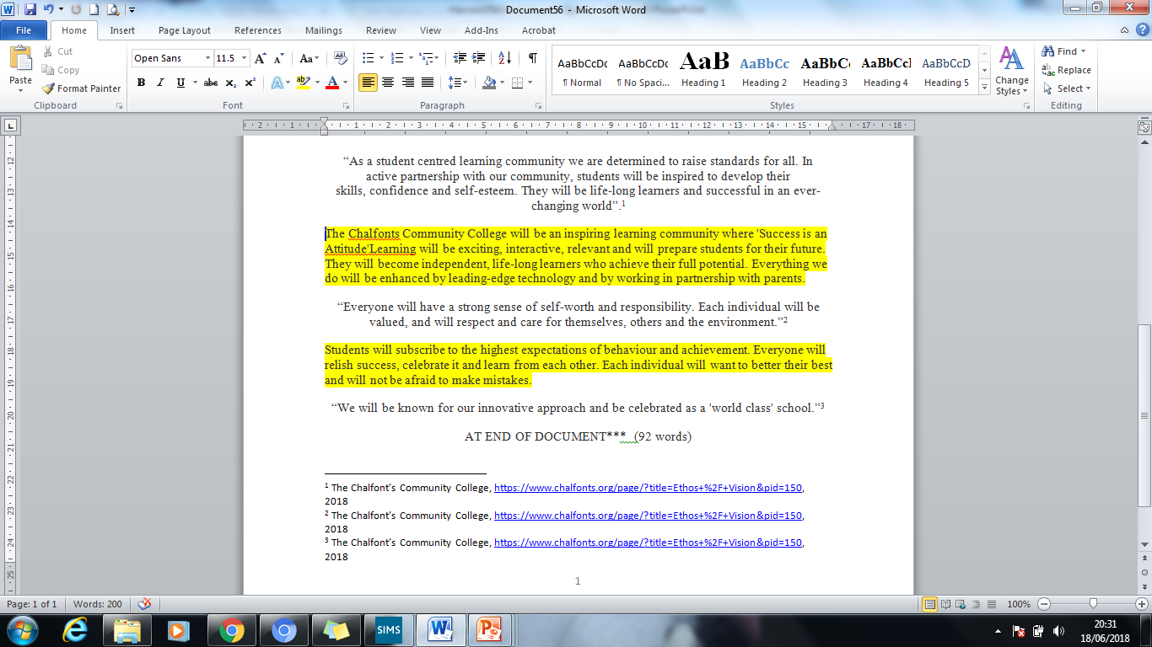

BIBLIOGRAPHY
The last page to all essays should contain a full Bibliography which identifies in a list all the sources you have used. Make sure it’s titled!
Books
Books should be listed in alphabetical order. Listing the following details:
- Author, Title, Publisher, Date Published
So an example being:
- Adams, C. How To Guide to Harvard Referencing. Chalfont’s Press. 2018
Websites
Websites should be listed in alphabetical order. Listing the following details:
- The article title, the website, the link, date published
So an example would be;
- How to Guide at Chalfont’s. www.chalfonts.org. https://www.chalfonts.org/ 2018
Films/TV Programmes
In drama it is frequent we want to quote films or television programmes so it’s important to know how to do this too. Listing the following details:
- Title of film/tv, the date it was released, the director of the piece
So an example would be:
- Becoming An Actor. (2018) Mrs Adams.

SECTION EIGHT: Independent Study/Homework
Homework in GCSE drama usually consists of you spending time building your coursework. Remember; an assessor can tell if you have rushed and done your coursework at the last minute or if you have developed and built it over time.
You must keep up with log books, type up your coursework and learn your lines. In order to meet deadlines you need to dedicate 1 hour a week (at least) to your drama homework. This will be detailed on Show My Homework.

Research
- Read plays
- Internet (Bitesize is a good place to start)
- Books
- Magazines
- Interviews
- Watching LIVE Theatre
- Watching recorded performance

Coursework
- Writing up journals/notes
- Research relevant to assignment
- Checking unit criteria
- Layout & Presentation
- Identify points you need clarification for

1
HOUR
WEEKLY
Experience
- Get involved in the Drama Department – ask for extra responsibility
- Get involved in Extra-Curricular activities
- Workshops available locally
- Join an Amateur Dramatics Company
- Network with other Performing Arts Students

Rehearse
- Learn Lines
- Devise Scenes
- Ideas to bring to class
- Practice Vocal Techniques
- Score your script/lyrics
- Rehearse Physical Techniques
- Video yourself and analyse

SECTION NINE: Reading List
This is not an exclusive list but a helpful resource to get you started.

PLAYS
Title | Playwright | Tick
Bouncers | John Godber
Shakers | John Godber
Teechers | John Godber
Punk Rock | Simon Stephens
Mother Said I Never Should | Charlotte Keating
Curious Incident of the Dog in the Night Time | Mark Haddon
Girls Like That | Evan Placey
Five Kinds of Silence | Shelagh Stephanson
Find Me | Olwen Wymark
Two | Jim Cartwright
DNA | Dennis Kelly
Daisy Pulls it Off | Denise Deegan
Little Shop of Horrors | Ashman/Mankan
Stags and Hens | Willy Russell
** Plus anything by Shakespeare

SUPPORTING THEORY
Theoretical Books
The Empty Space | By Brook

Towards A Poor Theatre | By Grotowski

Developing A Character | By Stanislavski

The Theatre And Its Double | By Artaud

Devising By Frantic Assembly

HELPFUL WEBSITES
www.franticassembly.co.uk | http://www.rsc.org.uk
http://www.complicite.org | www.nationaltheatre.org.uk
www.whatsonstage.com | www.britishtheatreguide.info/
www.trestle.uk.com/student | https://www.equity.org.uk/

SECTION TEN: Trips & Enrichment

Throughout the course we will endeavour to provide experiences which will enrich your learning experience.
Trips are a vital learning tool in drama as you need to watch as many LIVE productions as possible in varying styles and genres.
As soon as trips have been organised please ensure they are paid for as soon as possible to ensure that planned trips can go ahead.
 | 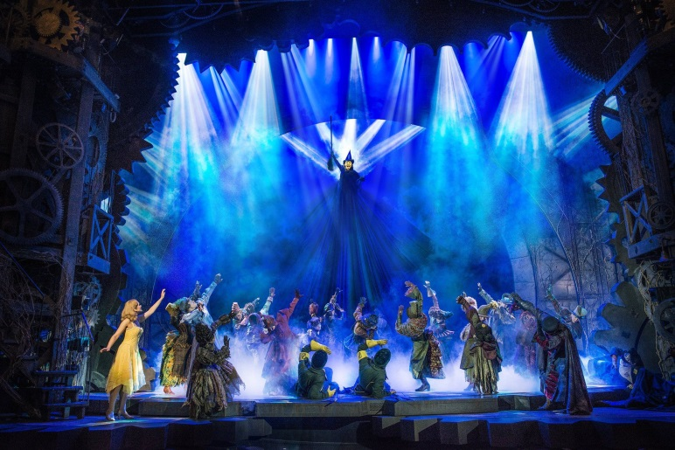
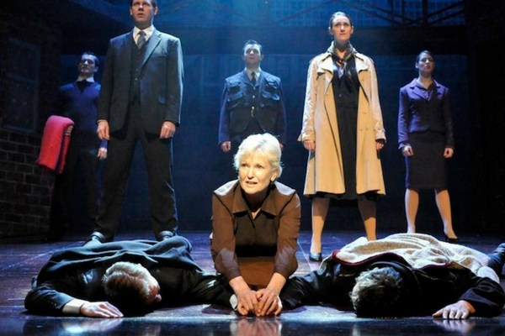 | 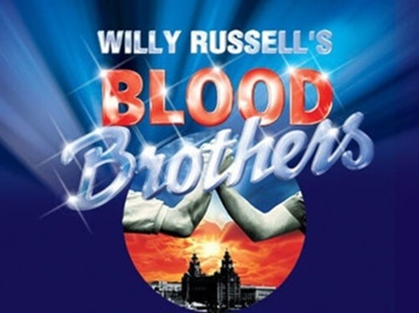
Wherever possible we will also bring in visiting lecturers, workshops and speakers to broaden the delivery of the course.

SECTION ELEVEN: Staff Contacts & Concerns

Your teachers are here to support you and guide you through the course. If ever you need clarification or are worried about an assignment please contact your teacher to discuss the problem.

Mrs Wells rebeccawells@chalfonts.org
Mrs Adams catherineadams@chalfonts.org
Mrs Evans lucyevans@chalfonts.org
Miss Adderley graceadderley@chalfonts.org
Mrs Yalden janineyalden@chalfonts.org

If the problem is not resolved and you would like further advice please contact one of the following;
Mr Vahora – Assistant Principal
imranvahora@chalfonts.org
Mr Michie – Assistant Principal
jamesmichie@chalfonts.org

