This second issue of our monthly careers newsletter for families celebrates National Careers Week 2021. Parents and carers, take a moment to share your own career story: what bit of advice would you pass on to your 14-year-old self? Read on for a round-up of events, activities and resources to help prepare young people for the fast-changing world of work…

**APPRENTICESHIPS p5 -6**

**UNDERSTANDING THE JOB MARKET p8 -9**

**UNIVERSITY p10 -11**

**NATIONAL CAREERS WEEK p1-4**

**BACK PAGE NEWS p13**

**PERSONAL GUIDANCE p12**

**WORK EXPERIENCE p7**

# **Image result for national careers week 2021 logoFocus on your future for #NCW2021**

National Careers Week from 1 – 6 March is the perfect opportunity for young people to focus on their futures. Here are 5 simple steps to get going.

1. **Download The Parents’ Guide to Careers**

****Get information to help teenage children make the right choices to create successful futures after GCSE and sixth form, including:

* Talking to your teen about their future
* Virtual work experience
* Vocations routes after GCSE or sixth form
* Apprenticeships, traineeships and internships
* University
* Starting a business



1. **Take a ‘lucky dip’ into different careers**

Go to [BBC Bitesize careers](https://www.bbc.co.uk/bitesize/careers) and just see what catches your eye. Where could your favourite subject take you?

1. **Split your career search into sections**

Don’t know where to start? Try splitting jobs up into different job types or ‘sectors’ of industry and work your way through:

* Visit the [National Careers Service](https://nationalcareers.service.gov.uk/explore-careers) and ‘explore careers by job category’
* [Explore careers by job sectors on BBC Bitesize](https://www.bbc.co.uk/bitesize/articles/zmdc382)
* Try our own starter-for-ten selection on the next page:

**NATIONAL CAREERS WEEK continued**

# **Industry sector starter-for-ten:**

1. **Animal care:** [Biologist](https://nationalcareers.service.gov.uk/job-profiles/biologist), [countryside ranger](https://nationalcareers.service.gov.uk/job-profiles/countryside-ranger), police dog handler, e[cologist](https://nationalcareers.service.gov.uk/job-profiles/ecologist), [RSPCA inspector](https://nationalcareers.service.gov.uk/job-profiles/rspca-inspector), [veterinary physiotherapist](https://nationalcareers.service.gov.uk/job-profiles/veterinary-physiotherapist) … to name but a few! [Start here](https://www.prospects.ac.uk/jobs-and-work-experience/job-sectors/environment-and-agriculture/jobs-working-with-animals) and get extra [inspiration from the RSPCA here](https://www.rspca.org.uk/utilities/jobs).
2. **Business**: Skills in management, finance, human resources, sales or marketing? You can transfer these to just about every industry going. [Find out more here](https://www.prospects.ac.uk/jobs-and-work-experience/job-sectors/business-consulting-and-management) and be [inspired by UK business heroes here](https://www.britishchambers.org.uk/page/uk-business-heroes).
3. **Computing, technology and digital:** From security architect to forensic expert, are plenty of roles to discover. Visit [Cyber Security Education](https://www.cybersecurityeducation.org/careers/) to find out more. Get [an overview of the UK’s IT industry here](https://www.prospects.ac.uk/jobs-and-work-experience/job-sectors/information-technology/overview-of-the-uks-it-industry).
4. **Construction**: Throw all visions of this being ‘a man on a building site’ out of the window! Visit [Go Construct](https://www.goconstruct.org/) to see huge range of exciting roles and career paths.
5. **Creative and media:** See our industry sector spotlight on pages 8 and 9. [Find out more at Discover! Creative Careers](https://discovercreative.careers/students-and-parents/) and [get an overview here](https://www.prospects.ac.uk/jobs-and-work-experience/job-sectors/creative-arts-and-design/overview-of-the-creative-arts-sector-in-the-uk).
6. **Engineering:** Aerospace, automobile, biomedical, chemical, civil, environmental … [get an overview of engineering here](https://www.prospects.ac.uk/jobs-and-work-experience/job-sectors/engineering-and-manufacturing) then [head to Neon](https://neonfutures.org.uk/resource/) to download resources and take the 'Meet the future you' quiz.
7. **Health and social care:** There are over 350 roles in the NHS! [Find out about healthcare careers here](https://www.healthcareers.nhs.uk/). Social care is about helping people live their lives in the community. Find out more at [Think Care Careers](https://www.skillsforcare.org.uk/Careers-in-care/Think-Care-Careers.aspx).
8. **Sports and leisure**: So many options beyond Premiership football player! Explore [working in the sports industry here](https://careers-in-sport.co.uk/). Look at the [British Association of Sport and Exercise Science website](https://www.bases.org.uk/spage-students-careers_centre.html) and [read their career guide](https://www.bases.org.uk/imgs/BASES_2020_Careers_Guide_Resource-nonmembers.pdf).
9. **Retail**: From warehouse to shop floor to head office, there are all sorts of jobs in retail. [Find out more here](https://www.prospects.ac.uk/jobs-and-work-experience/job-sectors/retail/jobs-in-retail) and [get ideas from live jobs here](https://www.retailchoice.com/).
10. **Science:** From animal technician to clinical scientist, pharmacist to crime scene investigator, [get started here](https://www.prospects.ac.uk/jobs-and-work-experience/job-sectors/science-and-pharmaceuticals/graduate-jobs-in-science-and-pharmaceuticals). Life sciences have helped fight Covid: [see how scientists deliver healthcare here](https://www.healthcareers.nhs.uk/explore-roles/healthcare-science/roles-healthcare-science/life-sciences).
11. **Figure out what you love doing – then how to earn a living from it**

Go to LinkedIn (you don’t have to sign in – young people have to be at least 16 years old to get an account) and type in something you love doing into the jobs search box at the top. For example, ‘mountain bike’, ‘animals’, ‘drawing’, ‘drama’. You’ll be amazed at what comes up – and gives you inspiration.

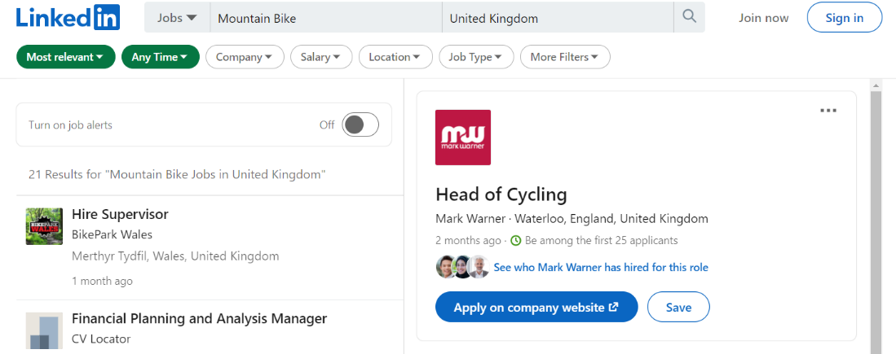



**NATIONAL CAREERS WEEK continued**

1. **Book on a free virtual event – try something new**

There are lots of different virtual events on in March to help you focus on your future during National Careers Week. Look through the ones below and book on: they’re all free.

|  |  |  |  |
| --- | --- | --- | --- |
| **Company/event title** | **Career type** | **Date/ time** | **More information/ registration** |
| BBC Young Reporter - National Careers Week Workshop | Journalism  Image result for bbc news logo | Mon 1 March,  12 – 1pm | <https://www.eventbrite.co.uk/e/bbc-young-reporter-national-careers-week-workshop-tickets-141290171707> |
| Digital Transformation UK: National Careers Week Special  by Lloyds Banking Group | Technology  Image result for lloyds banking group logo | Tues 2 March,  9 – 10.30am | <https://www.eventbrite.com/e/digital-transformation-uk-national-careers-week-special-tickets-140785797109> |
| Interactive Session with BT - Find your Career | Technology & business  Image result for bt logo | Tues 2 March,  5.30 – 6.30pm | <https://www.eventbrite.co.uk/e/interactive-session-with-bt-find-your-career-tickets-140791393849> |
| A Spotlight on your New Career with ICAEW chartered accountants | Accountancy  Image result for icaew logo | Wed 3 March,  5 – 6.30pm | <https://www.eventbrite.co.uk/e/a-spotlight-on-your-new-career-with-icaew-tickets-139456675671> |
| National Careers Week - Working in Esports  by Staffordshire University London | Careers in esports (sport competition using video games): from broadcasting to event planning and team management | Wed 3 March,  1 – 2pm | <https://www.eventbrite.co.uk/e/national-careers-week-working-in-esports-tickets-141435917637> |
| Interested in becoming a Healthcare Assistant? NHS Insight Event | Health  Image result for nhs logo | Thurs 4 March,  5 – 6pm | <https://www.eventbrite.co.uk/e/interested-in-becoming-a-healthcare-assistants-nhs-insight-event-tickets-140806525107> |
| National Careers Week - How to Get Your First Ever Job  by Staffordshire University London | Tips on how to get your first ever job while you're still at college or sixth from | Fri 5 March,  1 – 2pm | <https://www.eventbrite.co.uk/e/national-careers-week-how-to-get-your-first-ever-job-tickets-141444579545> |
| EY virtual taster day | Professional services helping companies make better decisions about business, finance and technology  Image result for ey logo | Fri 5 March,  10am – 2pm | <https://www.eventbrite.co.uk/e/ey-virtual-taster-day-tickets-138417796355> |
| Get into Retail and FMCG: Industry Spotlight Event featuring Arcadis & other employers | Retail & FMCG  (Fast-Moving Consumer Goods)Image result for arcadis logo | Tue 16 March,  6 – 7pm | <https://www.eventbrite.co.uk/e/get-into-retail-fmcg-industry-spotlight-event-arcadis-more-tickets-140978278827> |
| Get Job Ready: Video Interview Masterclass - supported by Experian | Giving young people the skills to ace video interviews and secure their career | Wed 17 March,  3 – 4pm | <https://www.eventbrite.co.uk/e/job-ready-video-interview-masterclass-supported-by-experian-tickets-141811021583> |
| Want to Work for the NHS? - Virtual Insight Event | Healthcare  Image result for nhs logo | Thurs 18 March,  5 – 6pm | <https://www.eventbrite.co.uk/e/want-to-work-for-the-nhs-virtual-insight-event-tickets-141662577583> |
| Job Ready: Assessment Centre Masterclass with Jaguar Land Rover | Learn how to tackle assessment centre tasks, used by some companies to examine and see if you’resuitable for the job  Image result for jaguar land rover logo white background | Wed 24 March, 3 – 4pm | <https://www.eventbrite.co.uk/e/job-ready-assessment-centre-masterclass-with-jaguar-land-rover-tickets-141814598281> |

**APPRENTICESHIPS**

## Missed out on apprenticeships events?

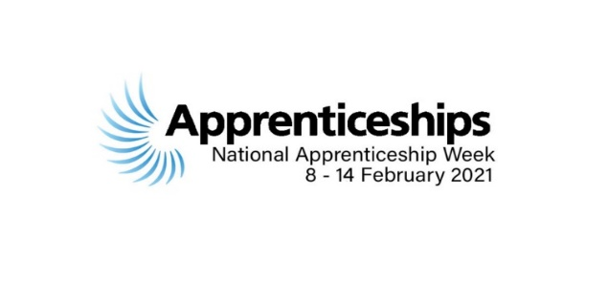

Want to find out more about post-16 and post-18 apprenticeship options?

Nearly 1000 students, parents and carers tuned in to the Bucks Skills Hub National Apprenticeship Week virtual events at the start of February where young apprentices shared their stories.

If you missed out – or want to watch again –, the recordings are now available on YouTube. Click on the links below and watch together with your son or daughter.

**An Introduction to Apprenticeships   
for Years 7-9**

* What exactly is an apprenticeship?
* Who should consider doing one?
* Why are apprenticeships different to other post-16 routes?
* What are the different levels of apprenticeships?
* Where are vacancies publicised?
* How does applying for an apprenticeship differ to applying for university?

[**Watch the recording here**](https://youtu.be/qCYRSExAFts)

**Finding and Applying for An Apprenticeship for Years 10-13**

* What are the different levels of apprenticeship?
* What does apprenticeship training look like?
* Which industry sectors offer apprenticeships?
* How do apprenticeship standards work?
* What’s the application timeframe and how does it compare to UCAS?

Plus top tips on:

* How, when and where to apply
* What employers are looking for
* How to make a successful application
* How to develop a professional online presence

[**Watch the recording here**](https://youtu.be/DS-8fgmJuo4)

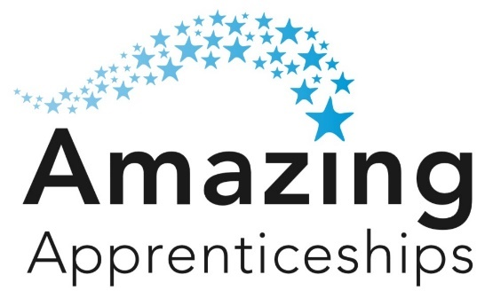

**Explore apprenticeships from home**

Get the latest advice and guidance from the National Apprenticeship Service from the monthly Amazing Apprenticeships Parents’ Pack**.**

**Watch out for the new** **Parents’ Activity Pack** coming soon which focuses on activities, interviews with employers and ideas on how to engage in discussions about apprenticeships at home.

[Find out more here](https://amazingapprenticeships.com/parents/)

**APPRENTICESHIPS continued**

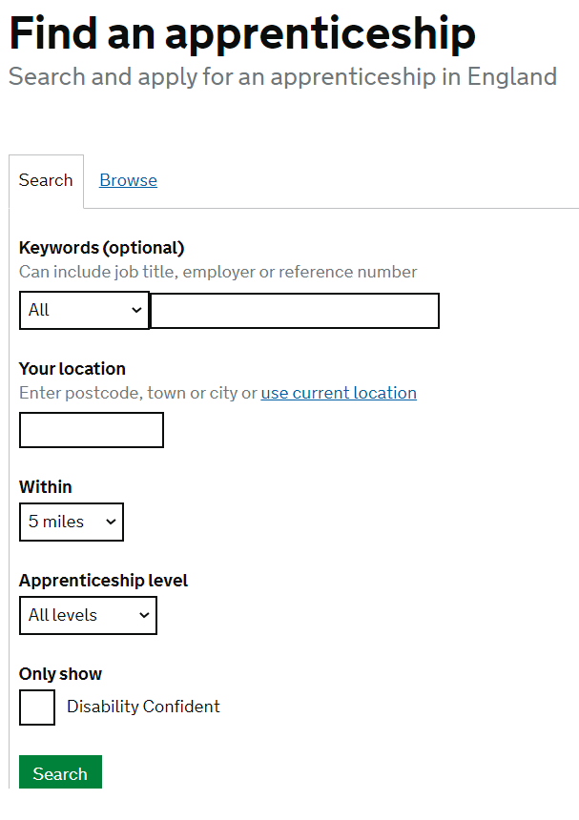

# **Live apprenticeship opportunities**

Looking for an apprenticeship? Head over to   
[www.gov.uk/apply-apprenticeship](http://www.gov.uk/apply-apprenticeship) and search current opportunities.   
Below, we’ve listed just a few of the latest school/college leaver jobs and apprenticeships at local and national employers:

**Ridgepoint Homes:**   
This residential development company based in High Wycombe is offering a Site Manager Apprenticeship. [Find out about Ridgepoint Homes here](https://ridgepointhomes.co.uk/) and [email Sarah Peace](mailto:sarah.peace@citb.co.uk), Construction Industry Training Board Engagement Advisor, for more info and to apply.

##### **Martin-Baker:** Apply before mid-March for engineering apprenticeships with the world-leading aerospace ejection seat manufacturer based in south Bucks. [Visit Martin-Baker’s website for more information and to apply.](https://martin-baker.com/careers/apprenticeships/)

[](https://martin-baker.com/careers/apprenticeships/)**Pfizer:** Apply **before 10 March** for apprenticeships for a career with one of the world’s largest science companies in both scientific and non-scientific roles including project manager, laboratory scientist, marketing manager, engineer, business administrator, accountant. [Find out more here](https://www.pfizer.co.uk/apprenticeships) and [view current opportunities here](https://www.apprenticesandgraduates.co.uk/vacancies/#pfizer-uk)

# **BT:** Apply for advanced, higher and degree level apprenticeships, including customer service, IT & technical support, software development, sales, electronics, data analysis and network design. [Find out more and apply here](https://www.bt.com/careers/early-careers/apprentices) and [find out about early careers here](https://www.bt.com/careers/early-careers)

**National Audit Office:** Apply for an accountancy apprenticeship **before 8 March**.   
[Find out more here](http://naoaccountancyscheme.co.uk/) and [apply here](https://nao-careers.force.com/xcdrecruit__Site_ExternalPositionDetails?id=aJm4I000000Caes)

**Morrisons:** Morrisons’ degree apprenticeships programme is now open, including roles in manufacturing, corporate, logistics, retail and food technology. Find out about [early careers here](https://www.morrisons.jobs/our-teams/early-careers/) and [degree apprenticeships here](https://www.morrisons.jobs/early-careers/degree-apprenticeships)

**Volkswagen Group:** Apply for an apprenticeship with one of the world's leading automobile manufacturers. [Find out more here](https://www.vwgroupapprenticeships.co.uk/) about career working as a Service Technician, Parts Advisor or Service Advisor.



**WORK EXPERIENCE**

# **Work experience: it’s still possible!**

Young people might not be able to go into the physical workplace – but the virtual world is your oyster. Look into virtual work experience (VWEx) opportunities now for the Easter and Summer holidays.

[Visit the Parents’ Guide to Work Experience](https://www.theparentsguideto.co.uk/post/virtual-work-experience) to see how it can make them stand out in a competitive world – and keep them focused on their studies.

It lists the many organisations that now offer VWEx, with links to find out more and apply. Check if age or geographical restrictions apply: they are often for 16+. We’ve also pulled out a few that caught our eye below...

**Free live VWEx run by practising vets**

****Interested in a career as a vet? Students in Years 10 – 12 can apply for free virtual work experience with Veterinary Mentor, a live programme uses computerized manikins to simulate real-life scenarios. You’ll follow the patient’s journey from diagnosis to treatment and follow up.

It runs for six-months, offering 30 hours of valuable experience, and takes place every third Sunday of the month **starting on 21 March**. Places are limited and depend on the quality of the application.

[Find out more and apply ASAP here](https://medicmentor.co.uk/veterinary-virtual-live-work-experience/)

# **Sign up for science VWEx by 15 March**

Students in Years 10 – 13 (age 14-18) can sign up for virtual work experience organised by the Science and Technology Facilities Council between June and August. The programme is also suitable for students with a non-STEM focus such as communications or art.

[Find more details and apply before the 15 March deadline here](https://stfc.ukri.org/about-us/work-with-us/work-experience/workexperienceral/)

# Image result for uptree**Get connected with Uptree**

[Log into Uptree](https://uptree.co/), the free professional network connecting Year 12 and 13s with employers at Mishcon de Reya law firm, JP Morgan, Google and more. These are during the school day, so you’ll need to get permission.

**Experience green careers in construction**

[Morgan Sindall](https://www.morgansindallconstruction.com/careers/) is offering four days of virtual work experience over Easter (**6 – 9 April** from 9.30am – 5pm) for students interested in finding out about green careers in the construction industry. [Apply **before 15 March**: register via Speakers for Schools here](https://www.s4snextgen.org/students/Take-Part)

# 

**UNDERSTANDING THE JOB MARKET**

# **What’s the future of work?**

Read this guide created for National Careers Week 2021 which helps you navigate the future of work – a daunting task at the best of times.

Be prepared for changing times and plan ahead. Find out about:

* The Fourth Industrial Revolution, the automation of traditional manufacturing using modern smart technology
* Jobs of the future: which occupations are in decline, where is demand increasing?
* The skills you need for the future
* Inspiring TED Talks and useful Twitter handles to follow

**Don’t forget what’s on your doorstep!**

It’s good to understand the big picture, but don’t lose sight of local opportunities. Find out about growing sectors such as space, high tech engineering, film & TV and healthcare right here in Bucks.

* [Download an overview of the local Buckinghamshire economy](https://oppsinbucks.org/discover-local-career-opportunities/)
* [Listen to Buckinghamshire Local Enterprise Partnership and local employers discuss ‘What’s on your doorstep?’](https://youtu.be/BWHsHGAz510)

# **Industry sector spotlight: Creative careers**

Each area of the economy has a different story to tell. We’ll take a look in each issue at a sector where job opportunities are growing: this month we feature creative careers.

**Nationally …** Before COVID struck, creative organisations involved in advertising, fashion, film and graphic design were thriving – and the sector will need new talent as it starts to recover. In 2019 the UK’s creative industry:

* contributed £115.9billion to the economy in 2019 (according to the Department of Digital, Culture, Media & Sport)
* Graphical user interface, text, application

  Description automatically generatedgrew by nearly a half (since 2010), making up just under 6% of the whole economy
* employed more than two million people and that number was growing - already up more than a third since 2011

[Find out more at Discover! Creative Careers](https://discovercreative.careers/students-and-parents/)

[Get an more detailed overview of the sector here](https://www.prospects.ac.uk/jobs-and-work-experience/job-sectors/creative-arts-and-design/overview-of-the-creative-arts-sector-in-the-uk)

**UNDERSTANDING THE JOB MARKET continued**

**Locally …** A pre-COVID count revealed that there are twice as many creative industry jobs within the Buckinghamshire economy than the national average. Film and TV roles make up a big part of these. Find out about [the skills needed to get into film, TV, VFX, animation and games here](https://www.screenskills.com/careers/).



**Pinewood Studios**, the home of the British film industry and the James Bond and Star Wars franchises, is located within Buckinghamshire and has big ambitions to grow. [Explore behind the scenes of a Pinewood film set here](Explore%20behind%20the%20scenes%20of%20a%20film%20set) and [discover the world-famous iconic studio here](https://pinewoodgroup.com/pinewood-today/careers?studio-name=all-pinewood-locations)

Beaconsfield is home to the **National Film & Television School**, one of the world’s top film schools. [Find out about Access NFTS](https://nfts.co.uk/access), a national programme to find, inform and inspire a new generation of film, TV and games talent.

Research [**CTV Outside Broadcasts**](https://www.ctvob.co.uk/) based in High Wycombe: think Strictly Blackpool to royal weddings, Crufts to the Ryder Cup.

Here are a couple of events which shed more light on creative careers:

# **Is your future in fashion?**

Passionate about fashion? From design and retail to **visual merchandising, buying and merchandising to garment technology, business management, marketing and communication, there are many routes into this creative industry.**

[Visit the Fashion Retail Academy Outreach Hub to find out more](https://www.fashionretailacademy.ac.uk/outreach-hub/), watch the 20 minute **‘Careers in Fashion Retail’ video and book a virtual open day:**

* Degree open day: **Wed 10 March**, 5.30 – 7.30pm
* Level 4 open day: **Tues 16 March**, 5.30 – 7.30pm
* Level 2/3 open day: **Thurs 18 March**, 5.30 – 7.30pm

[Book a virtual open day](https://portal.fashionretailacademy.ac.uk/events.aspx)

# Image result for norwich ignite series**Spark curiosity about creative careers**

Get practical insights into working in the creative industry with Norwich University of the Arts’ Ignite Series of free virtual workshops throughout March, including:

* My Career in TV: **Wed 10 March, 3.30 – 4pm**
* My Career in Animation: **Wed 24 March, 3.30 – 4pm**
* My Career in Games Design: **Wed 31 March, 3.30 – 4pm**

[Find out more and book here](https://www.nua.ac.uk/events/all/ignite-series/)

# Image result for what career live logo

**UNIVERSITY**

# **Register for free What University Live? and What Careers Live? virtual events**

Book now for this virtual careers event for 15 - 19 year olds which helps school leavers discover more about further education and apprenticeship options.

Speak to top universities and companies in real-time, get expert advice and benefit from one-to-one support to help young people kick-start their future.

**Log in** live on **Friday 19 March** from 10am to 3pm or **Saturday 20 March** from 11am to 3pm **to:**

* Chat to representatives from leading universities and employers
* Watch a packed programme of free talks
* Get one-to-one career advice
* Take part in free skills workshops

[Find out more and register here](https://www.whatcareerlive.co.uk/virtual-march-2021)

# **Attend the free University & Apprenticeship Search Virtual Fair**

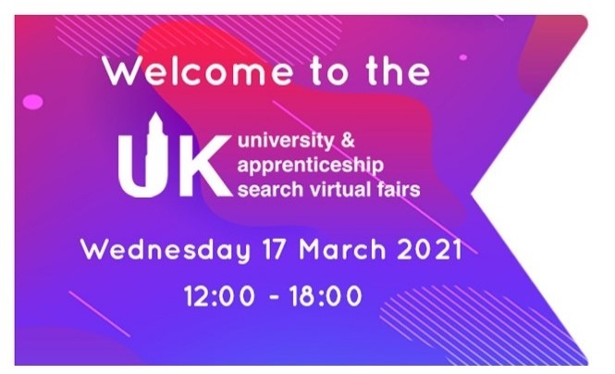Join the interactive UK University & Apprenticeship Search Virtual Fair on **Wednesday 17 March** from midday to 6pm – and explore all post-18 options in one place.

Meet Russell Group, red brick, modern and specialist universities, as well as colleges and apprenticeship providers.

Explore exhibition stands, view prospectuses and chat with admissions officers, student ambassadors, academics and recruitment teams. The event is great for:

* Year 11s: gain motivation and inspiration!
* Year 12s: explore all the fantastic higher education and career options available
* Year 13: helps you to decide on firm and insurance choices, or explore the apprenticeship path

[Find out more and book here](https://ukunisearch.vfairs.com/)

# **Prepare for the journey to uni**

Help young people to research and apply for university with Loughborough University’s ‘Parents and guardians inspiring minds’ week from **Monday 1 March to Saturday 6 March**.

Held during National Careers Week, it includes live and online resources from ‘How to help your child choose the right GCSEs’ to ‘How to prepare your child for university’. Book on to Q&A sessions with staff to ask further questions.

[Find out more and book your place](https://www.lboro.ac.uk/study/school-college-liaison/events/inspiringminds-parentsandguardians/)

**UNIVERSITY continued**

# **Book Bucks UTC open day for careers in construction and business**

Book on to Bucks UTC’s open event to find out about specialist employer-led courses in Computing and Building **Studies. Students can join in Year 10 or in Year 12.**

[Find out more and to book](https://buckinghamshireutc.co.uk/)

# **Image result for university of london logosFind out about London universities**

Find out about studying at six London universities all in one go at the free London Universities Group Roadshow Webinar – whether you’re starting university this year or in 2022.

* **Tuesday 2 March** from 5pm – 6pm if you’re considering commuting to the capital: [book here](https://us02web.zoom.us/webinar/register/WN_FSqi81ZaRjCi_p6ICVOVVw)
* **Thursday 4 March** from 6pm – 7pm if you’d be living in the capital while studying: [book here](https://us02web.zoom.us/webinar/register/WN_nejOWNpXTnyOa_ReeVncMA)

The London Universities Group is a collaboration between six universities that are all members of the University of London – City, Goldsmiths, Queen Mary, Royal Holloway, SOAS and St George’s.

# **Student outside Portsmouth's GuildhallRegister for Uni Week Live:**

Register for the virtual Uni Week Live from Wednesday 24 – Saturday 27 March run by the University of Portsmouth and discover everything you need to know before, during and after your application.

Get a taste of undergrad life, with helpful hints on everything from choosing a course, to making friends and moving away:

* Learn how to make important decisions like choosing a degree and a university
* Break down the UCAS process
* Explore wellbeing and mental health sessions
* Chat to current students in live Q&A sessions
* Find all the facts, figures and support related to student finance
* Meet the Student Union team
* Invite parents or guardians to evening sessions just for them

[Check out the full Uni Week Live programme and book your place](https://www.port.ac.uk/collaborate/schools-and-colleges/post-16-events/uni-week-live)

**PERSONAL GUIDANCE**

# **Book a call with the National Careers Service**

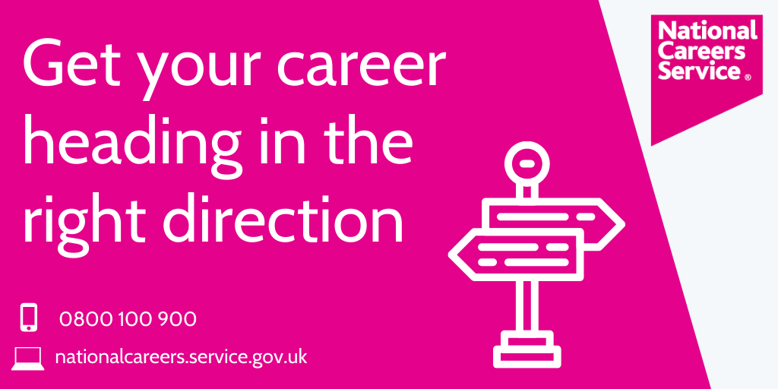Get information, advice and guidance to help you make decisions on learning, training and work from the National Careers Service, funded by the Government.

Parents, carers and students over 13 can speak to a trained adviser:

* call 0800 100 900
* between 8am to 8pm   
  Monday to Friday
* between 10am to 5pm   
  on Saturdays
* calls are free from landlines and most mobile numbers
* if you don’t want to call them, you can also: chat online, ask them to get in touch by email   
  or ask them to call you.

[Visit the National Careers Service website](https://nationalcareers.service.gov.uk/contact-us)

# **Free expert 1:1 careers guidance for young people in Bucks**

Higher or further education? Sixth form? Training or apprenticeship? Employment?

Talking about taking their next step with a trained careers counsellor can help young people choose which one's right for them.

If your son or daughter is in Year 11, 12 or 13, you can arrange a free virtual advice session (funded by The Careers & Enterprise Company) – now extended until the end of June.

[Click here to book](https://mailchi.mp/c5179a0fe2d7/whats-right-for-me-1-2-1-careers-advice), call 01494 927137 or email [info@bucksskillshub.org](mailto:info@bucksskillshub.org)

**BACK PAGE NEWS**

# **FOCUS ON SKILLS: Build skills together at home**

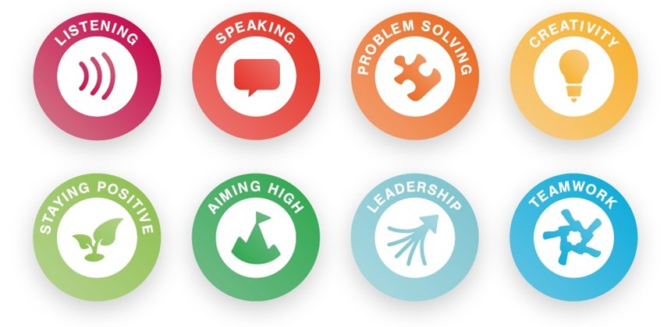Parents and carers can use the free Skills Builder Partnership website to help young people develop essential skills including: listening, speaking, problem solving, creativity, staying positive, aiming high, leadership and teamwork.

Talk about how their hobbies, interests, community connections and activities at home all help to build the skills your child needs for their future success – and how they contribute to personal statements, CVs and applications.

[Visit the Skills Builder Partnership](https://www.skillsbuilder.org/parents-and-carers)

**Wondering what to do after GCSEs?**

Look into what Berkshire College of Agriculture (BCA) offers at its virtual information evenings from Monday 22 – Wednesday 31 March. Book a 15-minute personal appointment from 5 – 7.35pm.

Book onto the open evening on Wednesday 5 May, 5pm - 7:30pm.

[Find out more and book here](https://www.bca.ac.uk/)

**Open up a career in conservation**

Dreamed of working in conservation, but don’t know where to start? Chester Zoo is offering virtual careers inspiration and advice from **Thursday 11 to Saturday 13 March** for young people aged 14+.

There is a charge (either £25 or £10) for the workshops, but the 20-minute career pathway webinars are free. [Find out more and download the 3-day schedule here](https://www.chesterzoo.org/what-we-do/careers-in-conservation/)

**Interested in becoming a barrister?**

Sixth formers interested in a career in law and becoming a barrister can sign up to a free Insight Online virtual Q&A panel run by the Inner Temple.Hear from practising barristers and judges about their journey to the Bar.

[Sign up here](https://innertemple.typeform.com/to/jPzsOn4X) for **10 March** 6 – 8pm and [sign up here](https://innertemple.typeform.com/to/VVwHYRCh) for **25 March** 6 – 8pm.