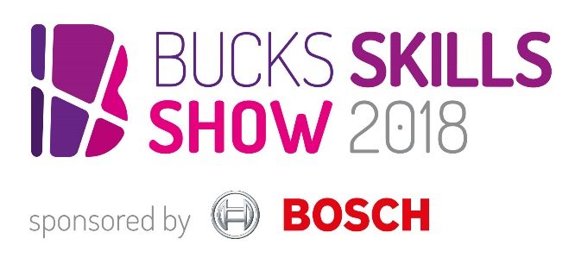

Publicising the Bucks Skills Show to parents and students

The Bucks Skills Show 2018 offers your students the opportunity for meaningful encounters with employers and education providers – and helps your school to meet the Gatsby benchmarks.

Please help us to spread the word to parents and students by featuring this article as soon as you can at the start of the autumn term:
- on your website;
- in newsletters/weekly bulletins;
- on school social media accounts.

Feel free to adapt the copy to suit your space. We’ve also provided a PDF poster to email round featuring key exhibitors and speakers.

Book free tickets now for the Bucks Skills Show 2018
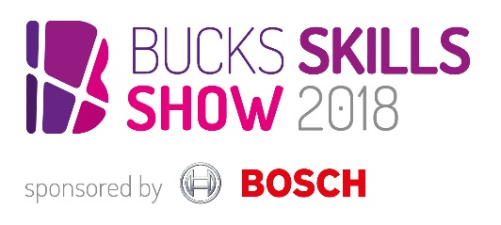
The countdown to the Bucks Skills Show 2018 sponsored by Bosch has begun – and we’re encouraging parents to book tickets and take students along on Saturday 13 October to The Gateway in Aylesbury, 9.30am to 3pm.

Organised by Buckinghamshire Skills Hub, the county’s largest interactive careers showcase opens young people’s eyes to the many different job opportunities available, letting them meet employers face-to-face and be motivated by high profile guest speakers.

The A-list speaker line-up includes Cabinet Minister David Lidington MP, Sir Anthony Seldon OBE and representatives from Google, ITV News, the Ministry of Sound, Bosch and the Civil Service.

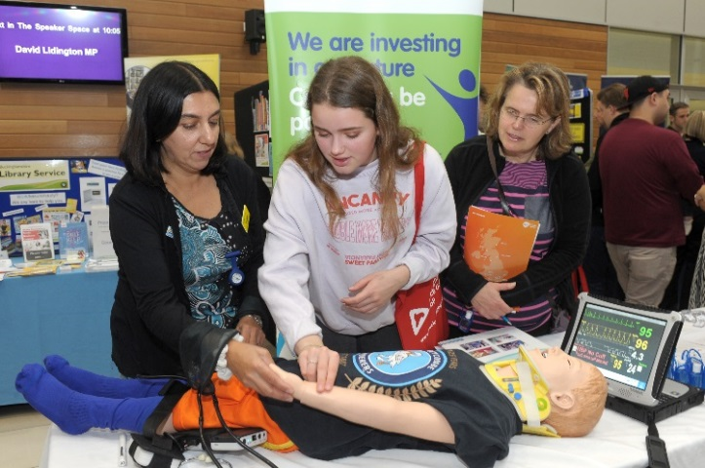
Employers represent a range of industry sectors:
- Creative industries (film, TV & music)
- Engineering, technology & manufacturing
- Life sciences, health & social care
- Business
- Retail, hospitality & leisure
- Public services
- Space industries
- Construction
- Plus meet education providers in the ‘next steps’ area.

Search ‘Bucks Skills Show 2018’ on Eventbrite.co.uk to book free tickets. Places are limited so we advise early booking. Follow @BucksSkillsShow on Twitter for updates.

